Green Pace Developer: Security Policy Guide Aiden Villanueva



Green Pace Secure Development Policy

Contents
Overview 2
Purpose 2
Scope 2
Module Three Milestone 2
Ten Core Security Principles 2
C/C++ Ten Coding Standards 3
Coding Standard 1 4
Coding Standard 2 5
Coding Standard 3 6
Coding Standard 4 7
Coding Standard 5 8
Coding Standard 6 9
Coding Standard 7 10
Coding Standard 8 11
Coding Standard 9 13
Coding Standard 10 14
Defense-in-Depth Illustration 15
Project One 15
1. Revise the C/C++ Standards 15
2. Risk Assessment 15
3. Automated Detection 15
4. Automation 15
5. Summary of Risk Assessments 16
6. Create Policies for Encryption and Triple A 16
7. Map the Principles 17
Audit Controls and Management 18
Enforcement 18
Exceptions Process 18
Distribution 19
Policy Change Control 19
Policy Version History 19
Appendix A Lookups 19
Approved C/C++ Language Acronyms 19

Overview
Software development at Green Pace requires consistent implementation of secure principles to all developed applications. Consistent approaches and methodologies must be maintained through all policies that are uniformly defined, implemented, governed, and maintained over time.

Purpose
This policy defines the core security principles; C/C++ coding standards; authorization, authentication, and auditing standards; and data encryption standards. This article explains the differences between policy, standards, principles, and practices (guidelines and procedure): Understanding the Hierarchy of Principles, Policies, Standards, Procedures, and Guidelines.

Scope
This document applies to all staff that create, deploy, or support custom software at Green Pace.

Module Three Milestone

Ten Core Security Principles
Principles | Write a short paragraph explaining each of the 10 principles of security.
- Validate Input Data | All user input must be validated before being used by the application. For example, string inputs must be validated for length (buffer overflow), contents (SQL injections) and not null. Furthermore, user intent should be defined clearly to make validation easy.
- Heed Compiler Warnings | Compiler-level warnings may not cause immediate crashes or apparent bugs, but must be handled before code reaches production. For example, a compiler warning may be thrown when a variable is declared but never used. These issues must be addressed to prevent unused, unreachable or misconnected code from causing downstream bugs and vulnerabilities.
- Architect and Design for Security Policies | Before writing any code or code edits, design documents should address all facets of this security policy, the OWASP and SEI CERT C++ standards and safe coding best practices. When creating design documents, pseudocode, flowcharts and other documentation and plans, authors should include sections for addressing known security concerns early.
- Keep It Simple | Obtuse code is hard to read, debug and prone to hidden errors and mistakes. While condensing code is not inherently negative, authors should ensure that the intent and function of code is always clear, either by design, in-line comments or other documentation. The age-old acronym KISS can be handy here: Keep It Simple and Succinct.
- Default Deny | Default Deny is explicitly disallowing all traffic, user interactions and system actions unless otherwise explicitly allowed by a rule, account permission or whitelist. Denying traffic and actions by default ensures that code only operates as intended.
- Adhere to the Principle of Least Privilege | Similar to Default Deny, PoLP states that users should only be given the minimum level of privileges that are required to perform the functions of that user account. By decreasing access to the minimum viable level, authors ensure that code can never be misused without external tampering.
- Sanitize Data Sent to Other Systems | Sanitizing Data in this context means ensuring that any data which leaves the system be cleaned of attributes like sensitive user information, system-only data and secure data like passwords, checksum hashes and authentication keys.
- Practice Defense in Depth | Defense in Depth means layering techniques of defense to ensure that a single vector cannot penetrate all of them. For example, by layering password protection, data encryption and a firewall, servers can be protected from threats at all three layers. In this case, a bad actor would need to separately bypass all three layers to gain access to the system.
- Use Effective Quality Assurance Techniques | Effective QA techniques include: unit, systems and integration testing automation; shift-left (early planned) testing, code reviews, user review and metric analysis. By starting early, tracking performance and security metrics and employing strategic testing authors ensure that bugs are caught early and confirm testing effectiveness.
- Adopt a Secure Coding Standard | Security standards are developed with much thought and foresight regarding computer science safety and the greater world. Choosing a standard to guide your security decisions is paramount to ensuring that the entire team approaches security from the same basis. Green Pace will heavily rely on the SEI CERT C++ coding standard.

C/C++ Ten Coding Standards
Complete the coding standards portion of the template according to the Module Three milestone requirements. In Project One, follow the instructions to add a layer of security to the existing coding standards. Please start each standard on a new page, as they may take up more than one page. The first seven coding standards are labeled by category. The last three are blank so you may choose three additional standards. Be sure to label them by category and give them a sequential number for that category. Add compliant and noncompliant sections as needed to each coding standard.

Coding Standard 1

Coding Standard | Label | Name of Standard
Data Type | STD-001-CPP (STR-050-CPP) | Guarantee that storage for strings has sufficient space  for character data and the null terminator. Copying strings to a buffer with insufficient size to store the characters and null terminator will cause a buffer overflow. Prevent this by ensuring that a buffer will always exist with the proper size to hold inbound strings.

Noncompliant Code
This code produces a buffer overflow error if the user input is larger than 12 characters.
#include <iostream>
void f() {
char buf[12];
std::cin >> buf;
}
This solution shows an attempt to remediate STR-050-CPP through use of the std::cin.width() function. However, it is still vulnerable as only bufOne uses the call. To be more appropriate, width() should be called before each operator line.
#include <iostream>
void f() {
char bufOne[12];
char bufTwo[12];
std::cin.width(12);
std::cin >> bufOne;
std::cin >> bufTwo;
}

Compliant Code
The compliant solution is to use std::string which can expand its own buffer when needed.
#include <iostream>
#include <string>
void f() {
std::string input;
std::string stringOne, stringTwo;
std::cin >> stringOne >> stringTwo;
}
This compliant solution assumes that the input from the file is at most 32 characters. Instead of inserting a null terminator, it constructs the std::string object based on the number of characters read from the input stream. If the size of the input is uncertain, it is better to use std::basic_istream::readsome() or a formatted input function, depending on need.
#include <fstream>
#include <string>
void f(std::istream &in) {
char buffer[32];
try {
in.read(buffer, sizeof(buffer));
} catch (std::ios_base::failure &e) {
// Handle error
}
std::string str(buffer, in.gcount());
// ...
}

Note: Stop here for the milestone. Complete this section for Project One in Module Six.
Principles(s):
1: Validate Input Data and 10: Adopt a Secure Coding Standard
Validating input boundaries ensures string operations do not write past allocated memory buffers, preventing arbitrary code execution and memory corruption.

Threat Level
Severity | Likelihood | Remediation Cost | Priority | Level
HIGH | Likely | Medium | P18 | L1

Automation
Tool | Version | Checker | Description Tool
SonarQube | v10.4 | cpp:S836 / S5802 | Detects buffer overflows and unbounded stream reads.
Cppcheck | v2.13 | bufferAccessOutOfBounds | Identifies potential array index overflow risks.
[Insert text.] | [Insert text.] | [Insert text.] | [Insert text.]
[Insert text.] | [Insert text.] | [Insert text.] | [Insert text.]

Coding Standard 2

Coding Standard | Label | Name of Standard
Data Value | STD-002-CPP (EXP-062-CPP) | Do not access the bits of an object representation that  are not part of the object’s value representation. Even if the bits are accessed in a well-defined manner, such as through an array of unsigned char objects, the values represented by those bits are unspecified or implementation-defined, and reliance on any particular value can lead to abnormal program execution.

Noncompliant Code
In this noncompliant code example, the complete object representation is accessed when
comparing two objects of type S. Per the C++ Standard, [class], paragraph 13 [ISO/IEC 14882-
2014], classes may be padded with data to ensure that they are properly aligned in memory. The
contents of the padding and the amount of padding added is implementation-defined. This can
lead to incorrect results when comparing the object representation of classes instead of the value
representation, as the padding may assume different unspecified values for each object instance.
#include <cstring>

struct S {
unsigned char buffType;
int size;
};

void f(const S &s1, const S &s2) {
if (!std::memcmp(&s1, &s2, sizeof(S))) {
// ...
}

Compliant Code
In this compliant solution, S overloads operator==() to perform a comparison of the value representation of the object.
struct S {
unsigned char buffType;
int size;
friend bool operator==(const S &lhs, const S &rhs) {
return lhs.buffType == rhs.buffType &&
lhs.size == rhs.size;
}
};
void f(const S &s1, const S &s2) {
if (s1 == s2) {
// ...

Note: Stop here for the milestone. Complete this section for Project One in Module Six.
Principles(s):
4 (Keep It Simple) and 9 (Use Effective Quality Assurance Techniques)
Overloading the == operator cleanly isolates equality logic from low-level memory padding noise, eliminating implementation-defined comparison errors.

Threat Level
Severity | Likelihood | Remediation Cost | Priority | Level
HIGH | Probable | High | P6 | L2

Automation
Tool | Version | Checker | Description Tool
Clang-Tidy | v17.0 | bugprone-suspicious-memory-comparison | Warns when comparing padding bits via raw bytes.
Cppcheck | v2.13 | memcmpOnStruct | Identifies memcmp used on structures containing alignment padding.
[Insert text.] | [Insert text.] | [Insert text.] | [Insert text.]
[Insert text.] | [Insert text.] | [Insert text.] | [Insert text.]

Coding Standard 3

Coding Standard | Label | Name of Standard
String Correctness | STD-003-CPP (STR-051-CPP) | Do not attempt to create a std::string from a null pointer.

Noncompliant Code
In this noncompliant code example, a std::string object is created from the results of a call
to std::getenv(). However, because std::getenv() returns a null pointer on failure, this
code can lead to undefined behavior when the environment variable does not exist (or some other
error occurs).
#include <cstdlib>
#include <string>
void f() {
std::string tmp(std::getenv("TMP"));
if (!tmp.empty()) {
// ...
}
}

Compliant Code
In this compliant solution, the results from the call to std::getenv() are checked for null
before the std::string object is constructed.
#include <cstdlib>
#include <string>
void f() {
const char *tmpPtrVal = std::getenv("TMP");
std::string tmp(tmpPtrVal ? tmpPtrVal : "");
if (!tmp.empty()) {
// ...
}
}

Note: Stop here for the milestone. Complete this section for Project One in Module Six.
Principles(s):
1 (Validate Input Data) and 5 (Default Deny)
Null-checking external inputs before string construction prevents null pointer dereferencing, denying invalid or missing parameters from crashing the application context.

Threat Level
Severity | Likelihood | Remediation Cost | Priority | Level
HIGH | Likely | Medium | P18 | L1

Automation
Tool | Version | Checker | Description Tool
SonarQube | v10.4 | cpp:S2259 | Performs null pointer dereference flow analysis.
Cppcheck | v2.13 | nullPointer | Scans for potential null pointer arguments to library calls.
Clang-Tidy | v17.0 | clang-analyzer-core.NullDereference | Flags direct object construction from unverified pointers.
[Insert text.] | [Insert text.] | [Insert text.] | [Insert text.]

Coding Standard 4

Coding Standard | Label | Name of Standard
SQL Injection | STD-004-CPP (SQL-051-CPP) | Prevent SQL Injection Through Parameterized Queries. Do not construct SQL statements by concatenating, interpolating, formatting, or otherwise embedding untrusted data directly into an SQL command.  All untrusted values supplied to an SQL statement shall be passed through parameterized queries, prepared statements, or equivalent database API binding mechanisms.  SQL injection occurs when data is interpreted as part of an SQL command rather than as a value.  Parameterized queries separate the SQL instruction from the data supplied to it, preventing bound values from being interpreted as SQL syntax.

Noncompliant Code
In this example, username contains SQL syntax, so the resulting query may be modified.

For example:

' OR '1'='1

could produce:

SELECT id, username, email
FROM users
WHERE username = '' OR '1'='1';

The application has allowed untrusted input to become part of the SQL program.
#include <string>

void findUser(Database& db, const std::string& username)
{
std::string query =
"SELECT id, username, email FROM users WHERE username = '" +
username +
"';";

db.execute(query);
}
std::format does not provide SQL injection protection.

Formatting a value into an SQL string is still dynamic SQL construction.
#include <format>
#include <string>

void findUser(Database& db, const std::string& username)
{
std::string query = std::format(
"SELECT * FROM users WHERE username = '{}';",
username
);

db.execute(query);
}

Compliant Code
For compliant code, the username value is transmitted separately and cannot alter the SQL syntax.
#include <string>

void findUser(Database& db, const std::string& username)
{
auto statement = db.prepare(
"SELECT id, username, email "
"FROM users "
"WHERE username = ?;"
);

statement.bind(1, username);

statement.execute();
}

Note: Stop here for the milestone. Complete this section for Project One in Module Six.
Principles(s):
1 (Validate Input Data), 7 (Sanitize Data Sent to Other Systems), and 8 (Practice Defense in Depth)
Parameterizing queries structurally decouples executable SQL code from user-supplied input data, enforcing boundary sanitization prior to database interaction.

Threat Level
Severity | Likelihood | Remediation Cost | Priority | Level
HIGH | Likely | Medium | P8 | L2

Automation
Tool | Version | Checker | Description Tool
SonarQube | v10.4 | cpp:S2077 / S3649 | Detects dynamic string formatting and concatenation in SQL calls.
Clang-Tidy | v23.2 | SQL Injection | Flags unescaped string interpolations entering database layers.
Fortify SCA | v2023.12 | SQLI | Performs sink-to-source taint analysis on database execution functions.
[Insert text.] | [Insert text.] | [Insert text.] | [Insert text.]

Coding Standard 5

Coding Standard | Label | Name of Standard
Memory Protection | STD-005-CPP (MEM-051-CPP) | The C++ programming language adds additional ways to allocate memory, such as the operators new, new[], and placement new, and allocator objects. Unlike C, C++ provides multiple ways to free dynamically allocated memory, such as the operators delete, delete[](), and deallocation functions on allocator objects.  Do not call a deallocation function on anything other than nullptr, or a pointer returned by the corresponding allocation function.  Passing a pointer value to an inappropriate deallocation function can result in undefined behavior.

Noncompliant Code
In this noncompliant code example, the local variable s1 is passed as the expression to the
placement new operator. The resulting pointer of that call is then passed to ::operator
delete(), resulting in undefined behavior due to ::operator delete() attempting to
free memory that was not returned by ::operator new().
#include <iostream>
struct S {
S() { std::cout << "S::S()" << std::endl; }
~S() { std::cout << "S::~S()" << std::endl; }
};
void f() {
S s1;
S *s2 = new (&s1) S;
// ...
delete s2;
}
In this noncompliant code example, the call to malloc() is mixed with a call to delete.
#include <cstdlib>
void f() {
int *i = static_cast<int *>(std::malloc(sizeof(int)));
// ...
delete i;
}

Compliant Code
This compliant solution removes the call to ::operator delete(), allowing s1 to be
destroyed as a result of its normal object lifetime termination.
#include <iostream>
struct S {
S() { std::cout << "S::S()" << std::endl; }
~S() { std::cout << "S::~S()" << std::endl; }
};
void f() {
S s1;
S *s2 = new (&s1) S;
// ...
}
In this compliant solution, the pointer allocated by std::malloc() is deallocated by a call to std::free() instead of delete.
#include <cstdlib>
void f() {
int *i = static_cast<int *>(std::malloc(sizeof(int)));
// ...
std::free(i);
}

Note: Stop here for the milestone. Complete this section for Project One in Module Six.
Principles(s):
3 (Architect and Design for Security Policies) and 10 (Adopt a Secure Coding Standard)
Enforcing proper deallocation function pairing (malloc/free vs new/delete) maintains heap integrity, averting corruption vulnerabilities such as double-frees and heap exploitation.

Threat Level
Severity | Likelihood | Remediation Cost | Priority | Level
HIGH | Likely | Medium | P18 | L1

Automation
Tool | Version | Checker | Description Tool
SonarQube | v10.4 | cpp:S5001 | Identifies mismatched allocation/deallocation calls.
Clang-Tidy | v17.0 | unix.MismatchedDeallocator | Detects freeing objects with inappropriate deallocation functions.
[Insert text.] | [Insert text.] | [Insert text.] | [Insert text.]
[Insert text.] | [Insert text.] | [Insert text.] | [Insert text.]

Coding Standard 6

Coding Standard | Label | Name of Standard
Assertions | STD-006-CPP (AST-050-CPP) | Do Not Use Assertions for Runtime Error Handling. The assert() macro and equivalent assertion mechanisms shall only be used to verify conditions that indicate programmer errors or violated internal invariants.  In C++, the standard assert() macro may be disabled by defining NDEBUG.  For example:  assert(function());  may execute function() in a debug build but not execute it at all in a release build.  This can produce inconsistent behavior between builds and can cause:  Missing validation  Skipped function calls  Missing security checks  Uninitialized state  Incorrect error handling  Bugs that only appear in release builds  Assertions are intended to detect violations of conditions that the programmer believes should be impossible during correct operation.  They are not a replacement for input validation or error handling.

Noncompliant Code
The validity of username depends on runtime input. If assertions are disabled, the validation disappears entirely.

An invalid username may then be passed to saveUser().
#include <cassert>
#include <string>

void createUser(const std::string& username)
{
assert(!username.empty());

saveUser(username);
}
When assertions are enabled:

connectToDatabase()executes

When assertions are disabled:

connectToDatabase() may not execute

The release build may therefore start the application without establishing the required database connection.
#include <cassert>

void initialize()
{
assert(connectToDatabase());

startApplication();
}

Compliant Code
For compliance, this validation remains active regardless of build configuration.
#include <stdexcept>
#include <string>

void createUser(const std::string& username)
{
if (username.empty())
{
throw std::invalid_argument(
"Username cannot be empty"
);
}

saveUser(username);
}
In this compliant code, the operation occurs regardless of assertion configuration.

The assertion may optionally remain as a programmer invariant, but program behavior does not depend on it.
#include <cassert>
#include <stdexcept>

void initialize()
{
bool connected = connectToDatabase();

if (!connected)
{
throw std::runtime_error(
"Unable to connect to database"
);
}

assert(connected);

startApplication();
}

Note: Stop here for the milestone. Complete this section for Project One in Module Six.
Principles(s):
2 (Heed Compiler Warnings) and 9 (Use Effective Quality Assurance Techniques)
Assertions can be compiled out in release builds (NDEBUG). Error handling must be explicit so runtime validation cannot be stripped in production deployments.

Threat Level
Severity | Likelihood | Remediation Cost | Priority | Level
MEDIUM | Unlikely | Low | P6 | L2

Automation
Tool | Version | Checker | Description Tool
SonarQube | v10.4 | cpp:S5911 | Flags assertions containing expressions with side effects or critical logic.
Cppcheck | v2.13 | assertWithSideEffect | Identifies side-effect execution dependent on assertion evaluation.
[Insert text.] | [Insert text.] | [Insert text.] | [Insert text.]
[Insert text.] | [Insert text.] | [Insert text.] | [Insert text.]

Coding Standard 7

Coding Standard | Label | Name of Standard
Exceptions | STD-007-CPP (ERR-058-CPP) | Not all exceptions can be caught, even with careful use of function-try-blocks.  When declaring an object with static or thread storage duration, and that object is not declared within a function block scope, the type’s constructor must be declared noexcept and must comply with ERR55-CPP Honor exception specifications.  Additionally, the initializer for such a declaration, if any, must not throw an uncaught exception (including from any implicitly constructed objects that are created as a part of the initialization).  If an uncaught exception is thrown before main() is executed, or if an uncaught exception is thrown after main() has finished executing, there are no further opportunities to handle the exception and it results in implementation-defined behavior.

Noncompliant Code
In this noncompliant example, the constructor for S may throw an exception that is not caught when globalS is constructed during program startup.
struct S {
S() noexcept(false);
};
static S globalS;

Compliant Code
This compliant solution makes globalS into a local variable with static storage duration, allowing any exceptions thrown during object construction to be caught because the constructor for S will be executed the first time the function globalS() is called rather than at program startup. This solution does require the programmer to modify source code so that previous uses of globalS are replaced by a function call to globalS().
struct S {
S() noexcept(false);
};
S &globalS() {
try {
static S s;
return s;
} catch (...) {
// Handle error, perhaps by logging it and gracefully
terminating the application.
}
// Unreachable.
}

Note: Stop here for the milestone. Complete this section for Project One in Module Six.
Principles(s):
3 (Architect and Design for Security Policies) and 4 (Keep It Simple)
Wrapping static/global object constructors in lazy-initialization functions prevents unhandled exceptions during pre-main execution phases, allowing clean exception catching.

Threat Level
Severity | Likelihood | Remediation Cost | Priority | Level
LOW | Likely | Low | P9 | L2

Automation
Tool | Version | Checker | Description Tool
SonarQube | v10.4 | cpp:S5008 | Flags potentially throwing constructors assigned to static global objects.
Clang-Tidy | v17.0 | cert-err58-cpp | Checks for static objects whose constructors may throw uncaught exceptions.
[Insert text.] | [Insert text.] | [Insert text.] | [Insert text.]
[Insert text.] | [Insert text.] | [Insert text.] | [Insert text.]

Coding Standard 8

Coding Standard | Label | Name of Standard
Integers | STD-008-CPP (INT-050-CPP) | The range of values that can be represented by either form of enumeration may include enumerator values not specified by the enumeration itself.  To avoid operating on unspecified values, the arithmetic value being cast must be within the range of values the enumeration can represent. When dynamically checking for out-of-range values, checking must be performed before the cast expression.

Noncompliant Code
This noncompliant code example attempts to check whether a given value is within the range of acceptable enumeration values. However, it is doing so after casting to the enumeration type, which may not be able to represent the given integer value. On a two’s complement system, the valid range of values that can be represented by EnumType are [0..3], so if a value outside of that range were passed to f(), the cast to EnumType would result in an unspecified value, and using that value within the if statement results in unspecified behavior.
enum EnumType {
First,
Second,
Third
};
void f(int intVar) {
EnumType enumVar = static_cast<EnumType>(intVar);
if (enumVar < First || enumVar > Third) {
// Handle error
}
}

Compliant Code
This compliant solution checks that the value can be represented by the enumeration type before performing the conversion to guarantee the conversion does not result in an unspecified value. It does this by restricting the converted value to one for which there is a specific enumerator value.
enum EnumType {
First,
Second,
Third
};
void f(int intVar) {
if (intVar < First || intVar > Third) {
// Handle error
}
EnumType enumVar = static_cast<EnumType>(intVar);
}
This compliant solution uses a scoped enumeration, which has a fixed underlying int type by default, allowing any value from the parameter to be converted into a valid enumeration value. It does not restrict the converted value to one for which there is a specific enumerator value, but it could do so as shown in the previous compliant solution.
enum class EnumType {
First,
Second,
Third
};
void f(int intVar) {
EnumType enumVar = static_cast<EnumType>(intVar);
}

Note: Stop here for the milestone. Complete this section for Project One in Module Six.
Principles(s):
1 (Validate Input Data) and 2 (Heed Compiler Warnings)
Validating integer bounds prior to casting prevents out-of-range value assignments to enumerations, averting memory corruption and unexpected branching logic.

Threat Level
Severity | Likelihood | Remediation Cost | Priority | Level
MEDIUM | Unlikely | Medium | P4 | L3

Automation
Tool | Version | Checker | Description Tool
Clang-Tidy | v17.0 | bugprone-enum-misuse | Checks for out-of-bounds value assignments to enums.
Cppcheck | v2.13 | checkCast | Detects integer conversions casting into insufficient representation types.
[Insert text.] | [Insert text.] | [Insert text.] | [Insert text.]
[Insert text.] | [Insert text.] | [Insert text.] | [Insert text.]

Coding Standard 9

Coding Standard | Label | Name of Standard
File Input Output | STD-009-CPP (FIO-050-CPP) | Do not alternately input and output from a file stream without an intervening positioning call.  The following scenarios can result in undefined behavior:  • Receiving input from a stream directly following an output to that stream without an intervening call to std::basic_filebuf<T>::seekoff() if the file is not at end-of-file  • Outputting to a stream after receiving input from that stream without a call to  std::basic_filebuf<T>::seekoff() if the file is not at end-of-file  No other std::basic_filebuf<T> function guarantees behavior as if a call were made to a standard C library file-positioning function, or std::fflush().

Noncompliant Code
This noncompliant code example appends data to the end of a file and then reads from the same file. However, because there is no intervening positioning call between the formatted output and input calls, the behavior is undefined.
#include <fstream>
#include <string>
void f(const std::string &fileName) {
std::fstream file(fileName);
if (!file.is_open()) {
// Handle error
return;
}

file << "Output some data";
std::string str;
file >> str;
}

Compliant Code
In this compliant solution, the std::basic_istream::seekg() function is called between the output and input, eliminating the undefined behavior.
#include <fstream>
#include <string>
void f(const std::string &fileName) {
std::fstream file(fileName);
if (!file.is_open()) {
// Handle error
return;
}

file << "Output some data";
std::string str;
file.seekg(0, std::ios::beg);
file >> str;
}

Note: Stop here for the milestone. Complete this section for Project One in Module Six.
Principles(s):
3 (Architect and Design for Security Policies) and 10 (Adopt a Secure Coding Standard)
Requiring explicit file positioning (seekg/seekp) between alternate read/write streams enforces predictable I/O operation behaviors as defined by C++ library specifications.

Threat Level
Severity | Likelihood | Remediation Cost | Priority | Level
LOW | Likely | Medium | P6 | L2

Automation
Tool | Version | Checker | Description Tool
SonarQube | v10.4 | cpp:S3608 | Warns on stream I/O mode changes without intervening seek calls.
[Insert text.] | [Insert text.] | [Insert text.] | [Insert text.]
[Insert text.] | [Insert text.] | [Insert text.] | [Insert text.]
[Insert text.] | [Insert text.] | [Insert text.] | [Insert text.]

Coding Standard 10

Coding Standard | Label | Name of Standard
Containers | STD-010-CPP (CRT-056-CPP) | Do not use pointer arithmetic on polymorphic objects.  The definition of pointer arithmetic from the C++ Standard, [expr.add], paragraph 7 [ISO/IEC 14882-2014], states the following:  “For addition or subtraction, if the expressions P or Q have type “pointer to cv T”, where T is different from the cv-unqualified array element type, the behavior is undefined.”  Pointer arithmetic does not account for polymorphic object sizes, and attempting to perform pointer arithmetic on a polymorphic object value results in undefined behavior.  Do not use pointer arithmetic, including array subscripting, on polymorphic objects.

Noncompliant Code
In this noncompliant code example, f() accepts an array of S objects as its first parameter. However, main() passes an array of T objects as the first argument to f(), which results in undefined behavior due to the pointer arithmetic used within the for loop.
#include <iostream>
// ... definitions for S, T, globI, globD ...
void f(const S *someSes, std::size_t count) {
for (const S *end = someSes + count; someSes != end; ++someSes) {
std::cout << someSes->i << std::endl;
}
}
int main() {
T test[5];
f(test, 5);
}
In this noncompliant code example, the for loop uses array subscripting. Since array subscripts are computed using pointer arithmetic, this code also results in undefined behavior.
#include <iostream>
// ... definitions for S, T, globI, globD ...
void f(const S *someSes, std::size_t count) {
for (std::size_t i = 0; i < count; ++i) {
std::cout << someSes[i].i << std::endl;
}
}
int main() {
T test[5];
f(test, 5);
}

Compliant Code
Instead of having an array of objects, an array of pointers solves the problem of the objects being of different sizes, as in this compliant solution.
#include <iostream>
// ... definitions for S, T, globI, globD ...
void f(const S * const *someSes, std::size_t count) {
for (const S * const *end = someSes + count;
someSes != end; ++someSes) {
std::cout << (*someSes)->i << std::endl;
}
}
int main() {
S *test[] = {new T, new T, new T, new T, new T};
f(test, 5);
for (auto v : test) {
delete v;
}
}

Note: Stop here for the milestone. Complete this section for Project One in Module Six.
Principles(s):
3 (Architect and Design for Security Policies) and 6 (Adhere to the Principle of Least Privilege)
Replacing array pointer arithmetic on polymorphic objects with pointer-to-pointer structures avoids incorrect byte-offset calculations due to derived class type size differences.

Threat Level
Severity | Likelihood | Remediation Cost | Priority | Level
HIGH | Likely | High | P9 | L2

Automation
Tool | Version | Checker | Description Tool
SonarQube | v10.4 | cpp:S2658 | Detects pointer arithmetic performed on derived dynamic objects.
Clang-Tidy | 17.0 | bugprone-pointer-arithmetic-on-polymorphic-object | Warns on array indexing over polymorphic pointer boundaries.
Cppcheck | v2.13 | pointerArithPolymorphic | Checks array offsets computed against base class references.
[Insert text.] | [Insert text.] | [Insert text.] | [Insert text.]

Defense-in-Depth Illustration
This illustration provides a visual representation of the defense-in-depth best practice of layered security.

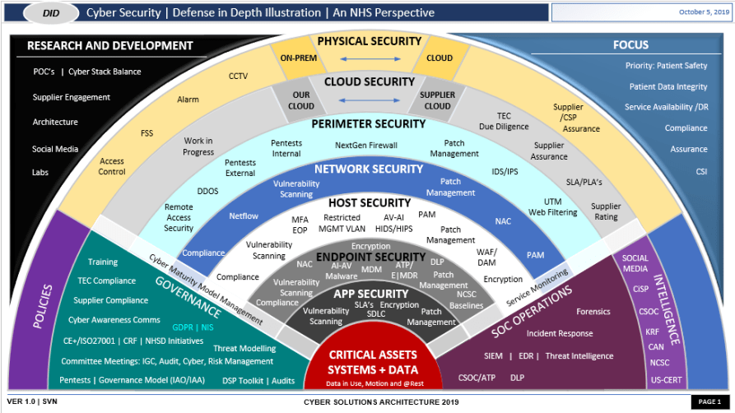

Project One
There are seven steps outlined below that align with the elements you will be graded on in the accompanying rubric. When you complete these steps, you will have finished the security policy.

Revise the C/C++ Standards
You completed one of these tables for each of your standards in the Module Three milestone. In Project One, add revisions to improve the explanation and examples as needed. Add rows to accommodate additional examples of compliant and noncompliant code. Coding standards begin on the security policy.

Risk Assessment
Complete this section on the coding standards tables. Enter high, medium, or low for each of the headers, then rate it overall using a scale from 1 to 5, 5 being the greatest threat. You will address each of the seven policy standards. Fill in the columns of severity, likelihood, remediation cost, priority, and level using the values provided in the appendix.

Automated Detection
Complete this section of each table on the coding standards to show the tools that may be used to detect issues. Provide the tool name, version, checker, and description. List one or more tools that can automatically detect this issue and its version number, name of the rule or check (preferably with link), and any relevant comments or description—if any. This table ties to a specific C++ coding standard.

Automation
Provide a written explanation using the image provided.
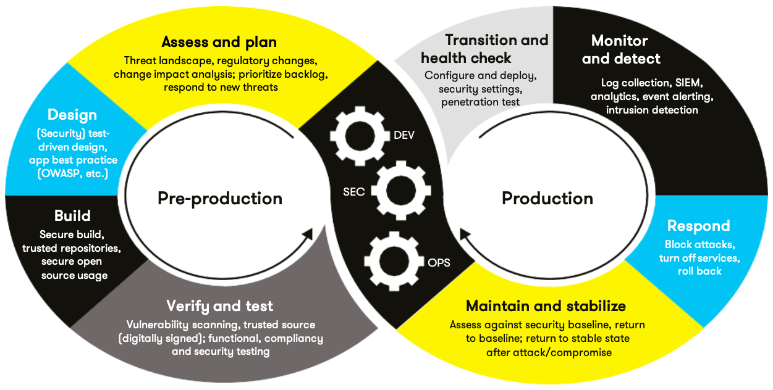
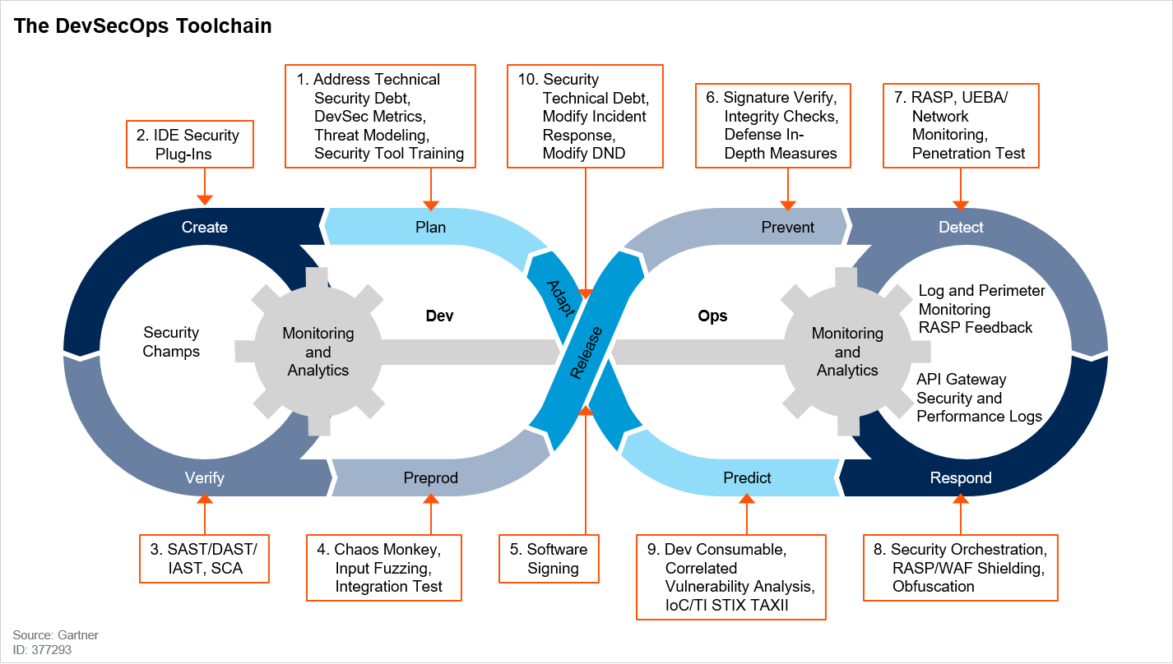

Automation will be used for the enforcement of and compliance to the standards defined in this policy. Green Pace already has a well-established DevOps process and infrastructure. Define guidance on where and how to modify the existing DevOps process to automate enforcement of the standards in this policy. Use the DevSecOps diagram and provide an explanation using that diagram as context.

To maintain security compliance across Green Pace projects without slowing development speed, security tool automation is integrated directly into every stage of our DevSecOps continuous delivery pipeline. Moving security "left" ensures vulnerabilities are caught during construction rather than late in testing or post-deployment.

1. Plan & 2. Create (IDE Security Plug-Ins):Security rules and SEI CERT C++ coding standards defined in this policy are embedded directly into developer environments via IDE plugins (i.e SonarLint, Clang-Tidy). Developers receive real-time static analysis feedback and remediation guidance as code is drafted, resolving technical security debt before pull requests are opened.

3. Verify (SAST, SCA, & IAST):Automated build gates (CMake/Ninja) integrated into our CI/CD pipeline (GitHub Actions / GitLab CI) execute Static Application Security Testing (SAST) using SonarQube v10.4, Clang-Tidy v17.0, and Cppcheck v2.13. Software Composition Analysis (SCA) automatically audits third-party dependencies for known CVEs. Pull requests containing High-Severity/Level-1 violations (such as SQL-051-CPP or STR-050-CPP) are automatically blocked from merging.

4. Preprod (Input Fuzzing & Dynamic Testing):During automated integration testing and nightly build pipelines, dynamic sanitizers (AddressSanitizer, UndefinedBehaviorSanitizer, Valgrind) and automated input fuzzing are executed against compiled binaries. This validates runtime memory integrity, pointer arithmetic safety (CRT-056-CPP), and I/O buffer management (FIO-050-CPP, STR-050-CPP) under stress.

5. Release & 6. Prevent (Software Signing & Defense-in-Depth):Before deployment, compiled binary artifacts undergo cryptographic signing and checksum verification to guarantee code provenance and prevent tampering. Deployment gates verify that build artifacts meet baseline security compliance metrics before moving into production environments.
7. Detect, 8. Respond, & 9. Predict (Runtime Protection & Analytics):In production, application logs and access traces are continuously aggregated into SIEM infrastructure to fulfill our Triple-A Accounting requirements. Real-time monitoring and anomaly detection provide continuous feedback back to the Plan stage, feeding security metrics and newly identified vulnerability insights directly into the backlog for ongoing remediation.

Summary of Risk Assessments
Consolidate all risk assessments into one table including both coding and systems standards, ordered by standard number.

Rule | Severity | Likelihood | Remediation Cost | Priority | Level
STD-006-CPP (AST-050-CPP) | Medium | Unlikely | Low | P6 | L2
STD-010-CPP (CRT-056-CPP) | High | Likely | High | P9 | L2
STD-007-CPP (ERR-058-CPP) | Low | Likely | Low | P9 | L2
STD-002-CPP (EXP-062-CPP) | High | Probable | High | P6 | L2
STD-009-CPP (FIO-050-CPP) | Low | Likely | Medium | P6 | L2
STD-008-CPP (INT-050-CPP) | Medium | Unlikely | Medium | P4 | L3
STD-005-CPP (MEM-051-CPP) | High | Likely | Medium | P18 | L1
STD-004-CPP (SQL-051-CPP) | High | Likely | Medium | P8 | L2
STD-001-CPP (STR-050-CPP) | High | Likely | Medium | P18 | L1
STD-003-CPP (STR-051-CPP) | High | Likely | Medium | P18 | L1

Create Policies for Encryption and Triple A
Include all three types of encryption (in flight, at rest, and in use) and each of the three elements of the Triple-A framework using the tables provided.
  - Explain each type of encryption, how it is used, and why and when the policy applies.
  - Explain each type of Triple-A framework strategy, how it is used, and why and when the policy applies.

Write policies for each and explain what it is, how it should be applied in practice, and why it should be used.

- Encryption | Explain what it is and how and why the policy applies.
Encryption at rest | Definition: Protection applied to static data stored on disk, databases, or backup media.  How to apply: Implement AES-256 bit encryption across databases, file stores, and volume blocks using managed KMS keys.  Why & When: Prevents unauthorized access or physical storage theft. Mandatory for all production databases, configuration files, credentials, and persistent application data.
Encryption in flight | Definition: Protection applied to data moving across networks or internal IPC channels.  How to apply: Enforce TLS 1.3 (minimum TLS 1.2) for all external REST/gRPC interfaces and internal microservice-to-microservice communications.  Why & When: Prevents packet sniffing and man-in-the-middle attacks. Mandatory for all network endpoints, database driver connection strings, and external API integrations.
Encryption in use | Definition: Protection applied to sensitive data active in volatile memory during processing.  How to apply: Secure memory enclaves (Intel SGX/AMD SEV), dynamic memory scrubbing (memset_s), and zeroing sensitive buffers directly after execution.  Why & When: Protects against cold-boot memory dumps and process memory snooping. Mandatory when handling private user keys, session tokens, and passwords in heap memory.

- Triple-A Framework* | Explain what it is and how and why the policy applies.
Authentication | Definition: Verification of system identity for users and programmatic callers.  How to apply: Enforce Multi-Factor Authentication (MFA) via OAuth2/OIDC for human logins and mTLS/signed JWTs for system microservices.  Why & When: Ensures only valid entities access resources. Applies to all user logins, administrative API entry points, and machine-to-machine integrations.
Authorization | Definition: Enforcement of permission boundaries controlling resource access.  How to apply: Implement Role-Based Access Control (RBAC) and Attribute-Based Access Control (ABAC) adhering strictly to Principle 6 (Least Privilege).  Why & When: Restricts actions based on verified roles. Controls user access levels, database record queries, system administrative controls, and file modifications.
Accounting | Definition: Tracking and auditing of system activities, changes, and access events.  How to apply: Centralized append-only logging exported directly to SIEM infrastructure (Elastic/Splunk) with automated alerting.  Why & When: Ensures non-repudiation and policy compliance. Mandatory for recording all user logins, database schema modifications, permission changes, user additions, and sensitive file operations.

*Use this checklist for the Triple A to be sure you include these elements in your policy:

- User logins
- Changes to the database
- Addition of new users
- User level of access
- Files accessed by users

Map the Principles
Map the principles to each of the standards, and provide a justification for the connection between the two. In the Module Three milestone, you added definitions for each of the 10 principles provided. Now it’s time to connect the standards to principles to show how they are supported by principles. You may have more than one principle for each standard, and the principles may be used more than once. Principles are numbered 1 through 10. You will list the number or numbers that apply to each standard, then explain how each of these principles supports the standard. This exercise demonstrates that you have based your security policy on widely accepted principles. Linking principles to standards is a best practice.

Standard | Standard Name | Principle Numbers | Supported Principles Justification
STD-001-CPP | STR-050-CPP | 1, 10 | Validate Input Data ensures string lengths are validated before copy operations; Adopt a Secure Coding Standard standardizes safe string buffer usage.
STD-002-CPP | EXP-062-CPP | 4, 9 | Keep It Simple avoids raw byte comparisons; Use Effective Quality Assurance Techniques employs static analysis to catch unsafe memcmp calls.
STD-003-CPP | STR-051-CPP | 1, 5 | Validate Input Data checks getenv() returns for null; Default Deny halts object instantiation unless valid pointer data is guaranteed.
STD-004-CPP | SQL-051-CPP | 1, 7, 8 | Validate Input Data & Sanitize Data Sent to Other Systems clean input prior to execution; Practice Defense in Depth separates query execution logic from data.
STD-005-CPP | MEM-051-CPP | 3, 10 | Architect and Design for Security Policies plans clear allocation lifecycles; Adopt a Secure Coding Standard mandates matching new/delete or malloc/free pairs.
STD-006-CPP | AST-050-CPP | 2, 9 | Heed Compiler Warnings prevents relying on NDEBUG-suppressed code; Use Effective QA Techniques replaces assertions with explicit runtime exceptions.
STD-007-CPP | ERR-058-CPP | 3, 4 | Architect and Design for Security Policies catches initialization exceptions; Keep It Simple wraps static singletons in clear local function scopes.
STD-008-CPP | INT-050-CPP | 1, 2 | Validate Input Data checks integer ranges before conversion; Heed Compiler Warnings catches implicit truncation warnings during compilation.
STD-009-CPP | FIO-050-CPP | 3, 10 | Architect and Design for Security Policies structures predictable file streams; Adopt a Secure Coding Standard requires explicit seekg/seekp repositioning.
STD-010-CPP | CRT-056-CPP | 3, 6 | Architect and Design for Security Policies prevents pointer array miscalculations; Principle of Least Privilege restricts object manipulation through safe indirect pointers.

NOTE: Green Pace has already successfully implemented the following:

- Operating system logs
- Firewall logs
- Anti-malware logs
The only item you must complete beyond this point is the Policy Version History table.

Audit Controls and Management
Every software development effort must be able to provide evidence of compliance for each software deployed into any Green Pace managed environment.

Evidence will include the following:

- Code compliance to standards
- Well-documented access-control strategies, with sampled evidence of compliance
- Well-documented data-control standards defining the expected security posture of data at rest, in flight, and in use
- Historical evidence of sustained practice (emails, logs, audits, meeting notes)

Enforcement
The office of the chief information security officer (OCISO) will enforce awareness and compliance of this policy, producing reports for the risk management committee (RMC) to review monthly. Every system deployed in any environment operated by Green Pace is expected to be in compliance with this policy at all times.

Staff members, consultants, or employees found in violation of this policy will be subject to disciplinary action, up to and including termination.

Exceptions Process
Any exception to the standards in this policy must be requested in writing with the following information:

- Business or technical rationale
- Risk impact analysis
- Risk mitigation analysis
- Plan to come into compliance
- Date for when the plan to come into compliance will be completed

Approval for any exception must be granted by chief information officer (CIO) and the chief information security officer (CISO) or their appointed delegates of officer level.

Exceptions will remain on file with the office of the CISO, which will administer and govern compliance.

Distribution
This policy is to be distributed to all Green Pace IT staff annually. All IT staff will need to certify acceptance and awareness of this policy annually.

Policy Change Control
This policy will be automatically reviewed annually, no later than 365 days from the last revision date. Further, it will be reviewed in response to regulatory or compliance changes, and on demand as determined by the OCISO.

Policy Version History

Version | Date | Description | Edited By | Approved By
1.0 | 08/05/2020 | Initial Template | David Buksbaum
1.1 | 08/13/2026 | Updated security principle definitions and secure coding standards. | Aiden Villanueva | [Insert text.]
1.2 | 08/16/2026 | Added automation rules, risk assessment consolidation, encryption policies, Triple-A framework rules, and principle mappings. | Aiden Villanueva | [Insert text.]

Appendix A Lookups

Approved C/C++ Language Acronyms

Language | Acronym
C++ | CPP
C | CLG
Java | JAV

References
Carnegie Mellon University Software Engineering Institute. (2017). SEI CERT C++
coding standard: Rules for developing safe, reliable, and secure systems. Secure
Coding Wiki. Retrieved August 13, 2026, from cmu.edu

